Proof of Identity and Proof of Address Checklist

Proof of Identity Documentation - Over 18 applicants
The documents listed are the only documents that the GNVB will accept when processing applicants.
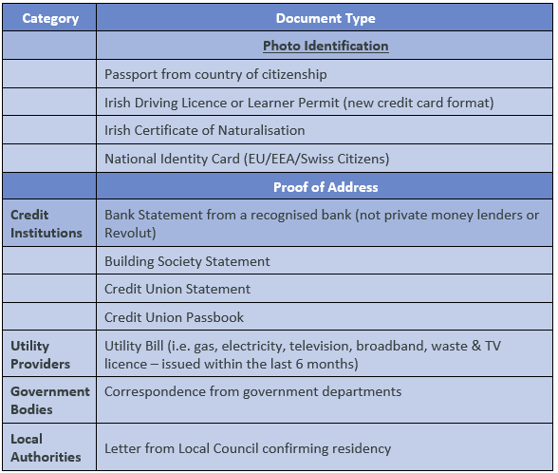
Proof of Address Documentation
- Must be dated within six months of the date the applicant signed the consent.
- Address must be the applicants current address and match address on the NVB1 Form.
- Full name must be included.
- Document must be on headed paper.

Proof of Identity Documentation
- Must be valid form of ID, current and not expired.
- Photograph must match the vetting subject and must be of high quality and clear.
- Name on the document must match the name on the NVB1 Form.
- Date of birth on the document must match the date provided on the NVB1 Form.

Proof of Identity Documentation - Under 18 Applicants
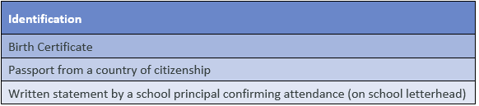
Proof of Address Documentation
- If the applicant does not have documentation outlined in the accepted documentation table, two documents must be submitted, one document must be the birth certificate.

Applicants outside of the island of Ireland
To commence the vetting process the applicant must scan and email a completed NVB1 form and proof of identity/address documents.
Prior to commencement of relevant work/activity the school must:
- Verify the original documents used in person and retain both.
- Take copies of ID and proof of address documents originally submitted.
- Date and verify.

